KUBERNETES
DAY1:
1. Get List of Namespaces in devhrk8sm1
kubectl get namespace
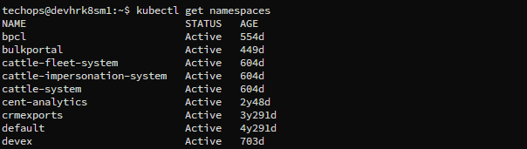
Total Namespaces count- 64
kubectl get namespace | wc -l
kubectl top node
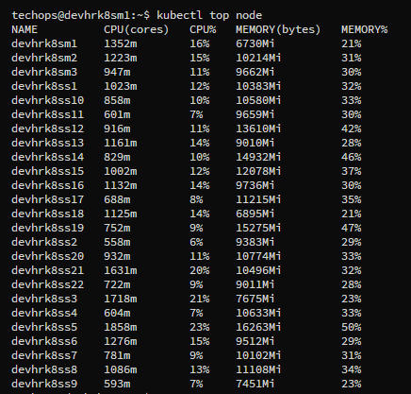
2. Get List of Nodes and Mention no. of Master and Worker Nodes along with their config using kubectl Only
kubectl get node
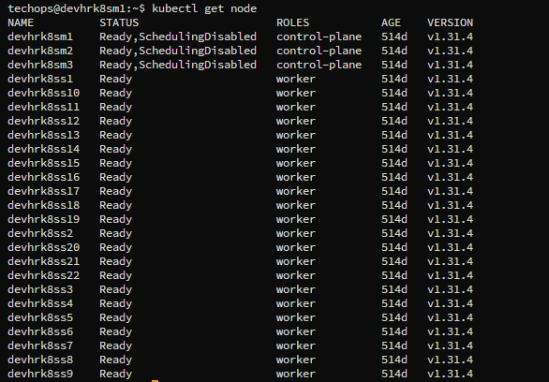
Master nodes –
kubectl get node | grep control-plane
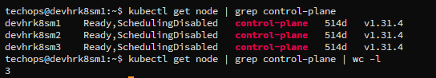
Worker nodes –
kubectl get node | grep worker
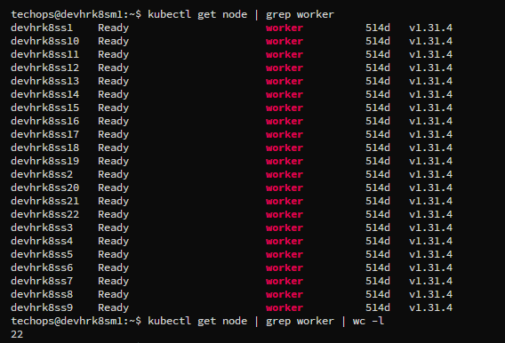
3. Get Number of deployments in every namespace
kubectl get deploy -A
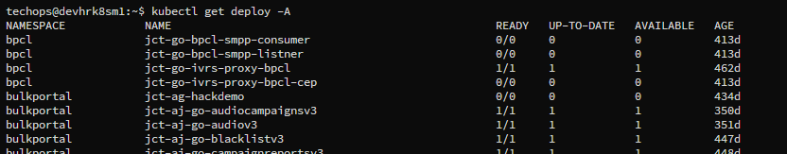
kubectl get deploy -n bpcl
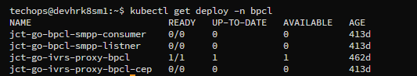

4. Get TOP 10 Pods from each namespace based on CPU Consumption
kubectl top pods -A --sort-by=cpu | head -11
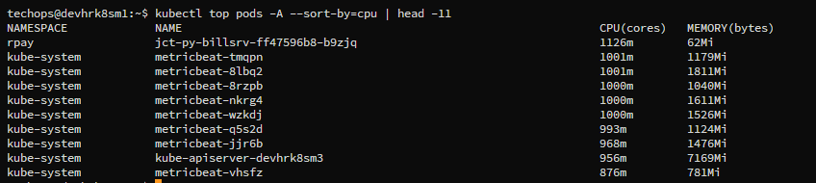
kubectl top pods -n bpcl --sort-by=cpu | head -11
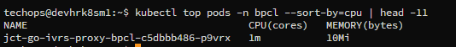

5. Get TOP 10 Pods from each namespace based on Memory Consumption
kubectl top pods -A --sort-by=memory | head -11
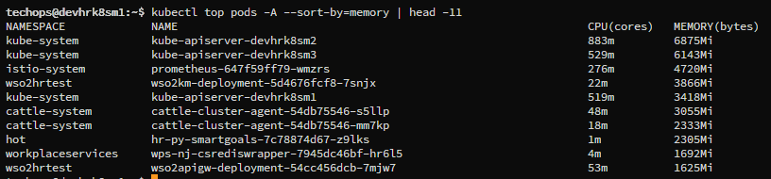
kubectl top pods -n rilcom --sort-by=memory | head -11
